Kevin Nunez 00323217 Linux Administration Ubuntu Server Networking Adrianna Holden Gouveia 10/10/2026
Network Administration Ubuntu Server
For start this assignment I prefer to know what we have in our server, just to start from a point. To see what we have installed we are going to use the command apt list -installed | less we use less if for some reason we can’t scroll up.
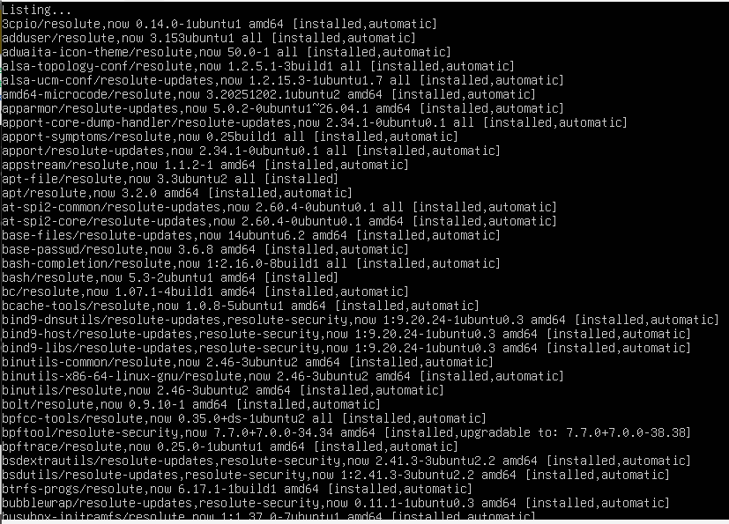
I want to see who is logged in my server, the w command show the information about users currently on the server, and their running process, for example: the current time, how much time the server has been running, how many users are currently logging, the system load average for the past 15 minutes, I think this command is great for checking our network.

We use the w command now to display the users online in our server.
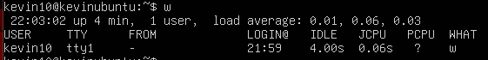
The id command is used to display user identification information, just need to type id , you can also use id +the user.
Last command can give login history for a specific username, if we don’t give any argument for this command we will get list of login history for all users, this command is amazing, full control and observation about our users, for me is last kevin10.
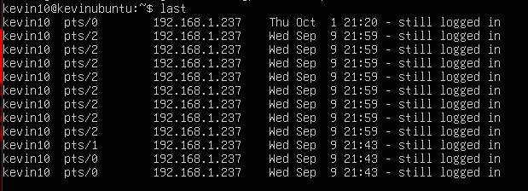

This command will help us to see all the users in our network, even if they are not connected in our server, the command is cat /etc/passwd | awk -F: ‘{print $1}’ this just going to print their names, I use the awk command to let me print the first field of information.
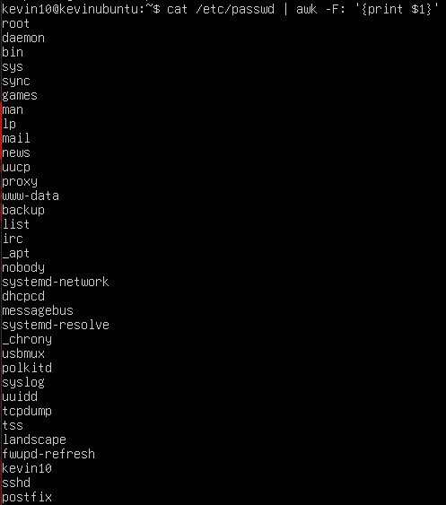

Now we are going to use a command without the awk to see where the users are allocated and do something with groups information.
Each line in the file has seven fields delimited by colon that contain the following information: Username. Encrypted password (x means that the password is stored in the /etc/shadow file). User ID number (UID). User’s group ID number (GID). Full name of the user (GECOS). User home directory. Login shell (defaults to /bin/bash). This is all the information we can get from the command cat /etc/passwd
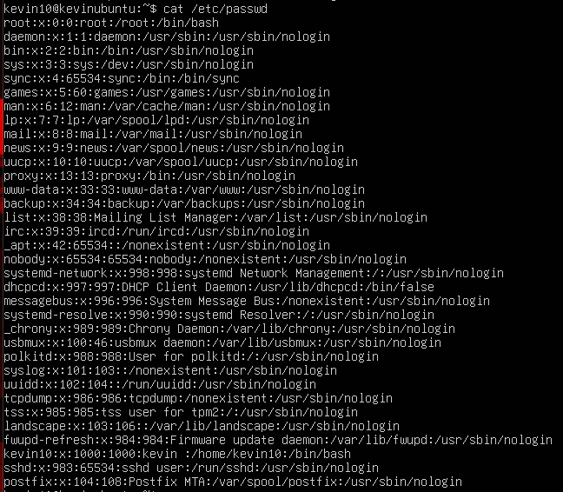

Now let’s find some information about groups, for this we use /etc/group this defines default system group entries for system that make the groups for support, the command is cat /etc/group
Group name: contains the name assigned to the group.
Group-password(x): x in this field indicates that shadows passwords are used.
GID: contains the group’s GID number.
Username-list: list of the users that are members of the group.
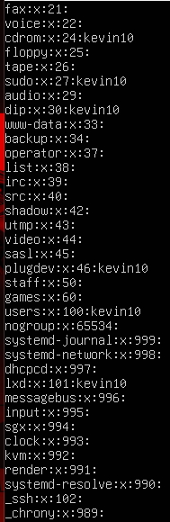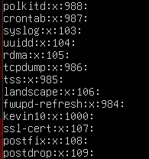

Now we are going to check some networking commands, like knowing your IP, DNS, Ports, and other important information. Ipconfig (interface configurator) is one of the most basic and commonly used commands for finding network details. It is also used to configure network interface parameters. We can use this command to get the IP address, MAC address, and MTU of available networks.
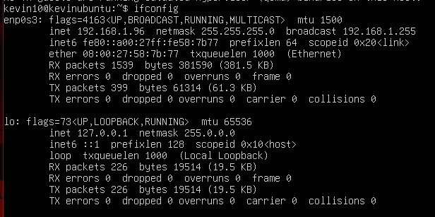
This command is cat /etc/resolv.conf. This allows us to find our DNS and IP address, this is the first difference in our ubuntu server but still works.
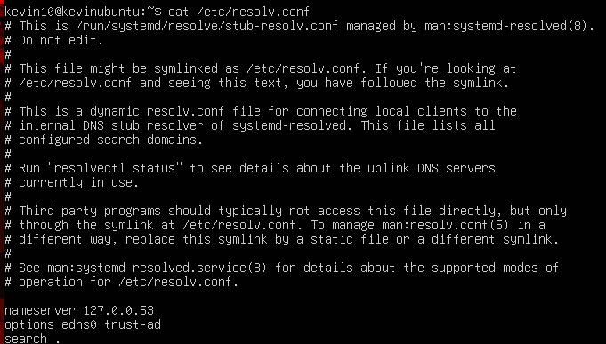
The command is netstat -a is used to display the information about the TCP and the UDP.
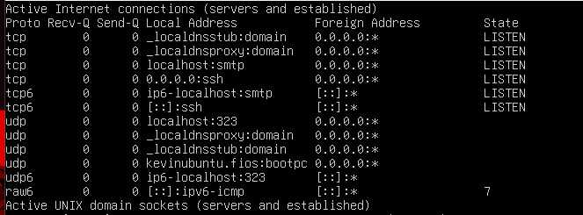
The command netstat -s gets all the details about our ports.
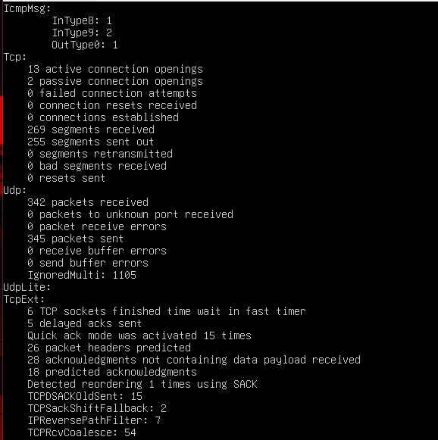
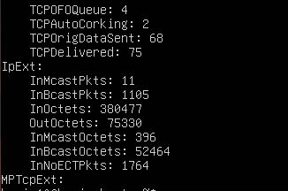
Now with the command whois amazon.com to display the information of one webpage.
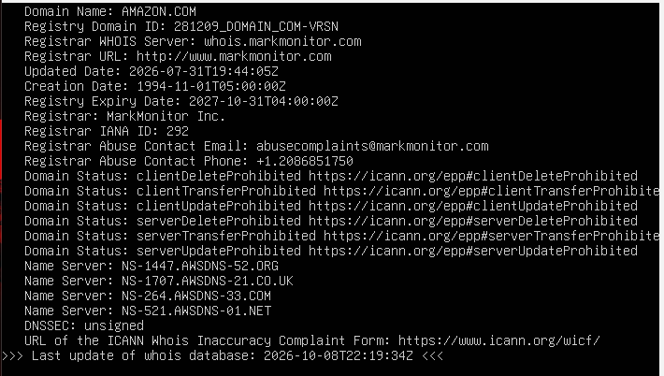

Now we going to use the firewall command for this we going to use the firewall-cmd –list-all to check all the ports and services, but first I become a root with sudo -i.
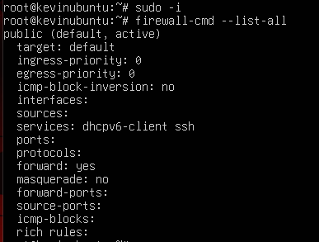
Now with the command systemctl firewalld, this allows us to see if the firewall is active and check the status of the firewall.
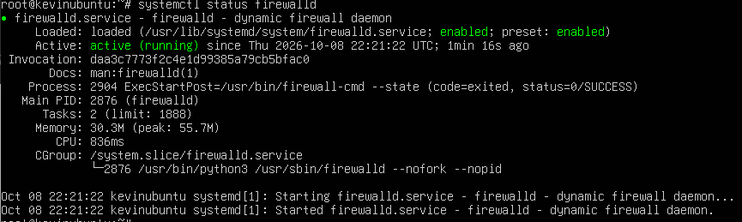

Users.sh Script
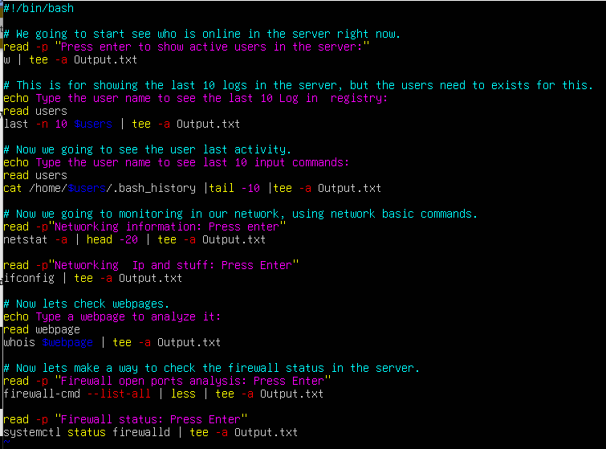
Read -p: This command read the user input before going into the next line.
tee -a: This command will display the output in the terminal and then append the output into a file.
Head and Tail -number: I used this as a combination to limit the output of information from large commands and display the information I wanted from a command. Head beginning. Tail at the end.
echo: the echo command outputs the strings of the written argument.
read $variable$: The read command will read the user input and stored as a variable.

How to run the script
For running this script, we need to be in root mode, for this we use the command su -i, because we need to be admin mode, and the script needs permission to be executable for this the command is chmod 755 +FileName
For run the script we run the command./FileName in my case is ./users.sh , the script start showing the user to press enter and show the users that is active right now.
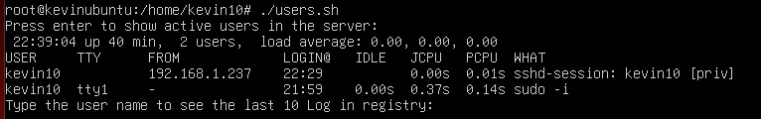
Now will ask for a user to check the last 10 logins, in the server.
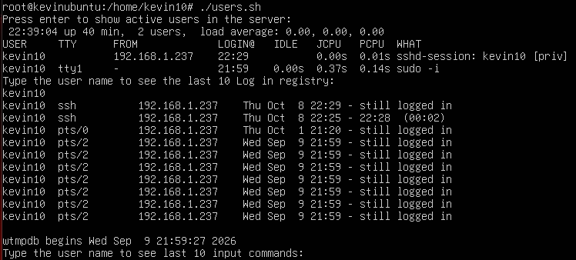
Now here we put the user to check the last 10 commands performed in the console, so after typing the username, it’s going to show the commands and the user.
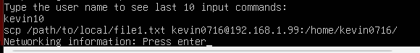

Now we are going to ask press enter to show the networking information, I set a limit in the script command to show just this part, but this can be change.
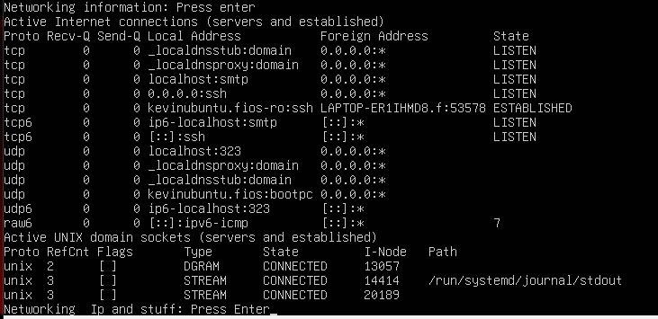
We pressed enter again to see the IP of the networking.
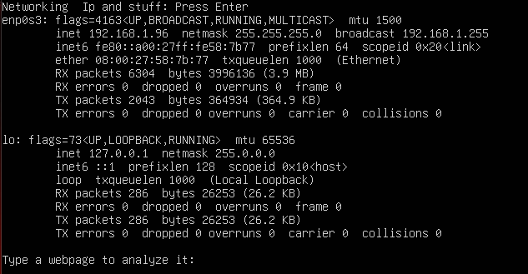

After this it will ask you for type a domain, to observes the webpages, this was made with the whois, in my case I use amazon.com but you can try different webpages.
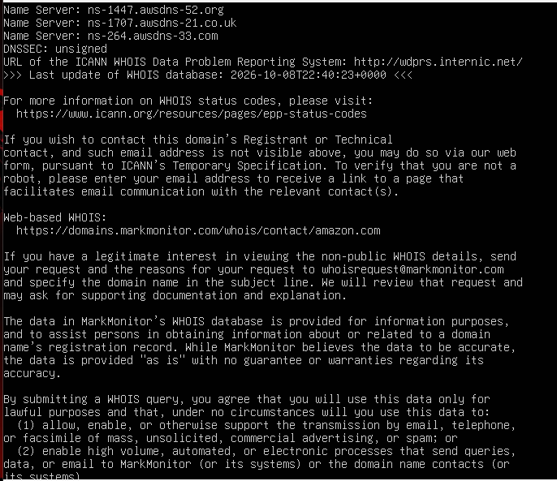

We press enter to display information about the firewall ports.
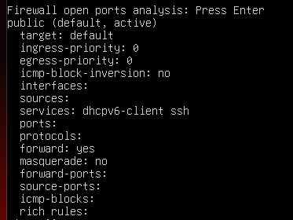
And we press enter again to display if the firewall is active.
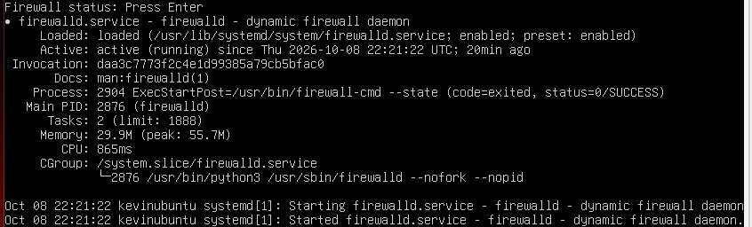

Why did I choose this script?
With this I hope I can cover the fundamentals of the materials we have on the webpage. With this script we can check status, connectivity, and check if everything is secure. Check what our users are doing on the server, check the command each user uses, check the information about the network, and most importantly, check the firewall. The whois can help more by checking the domain webpages, before using it.
Sources that I use
https://www.fosslinux.com/42935/linux-networking-commands.htm
https://www.educba.com/networking-commands/
https://javarevisited.blogspot.com/2010/10/basic-networking-commands-in-linuxunix.html#axzz79npqnTcH
https://linuxconfig.org/redhat-8-stop-start-firewall
https://www.configserverfirewall.com/ufw-ubuntu-firewall/ubuntu-check-firewall-status-ufw/
https://linux.die.net/man/8/ping
https://www.javatpoint.com/linux-networking-commands
https://www.redhat.com/sysadmin/7-great-network-commands
https://www.networkworld.com/article/3233306/more-ways-to-examine-network-connections-on-linux.html
https://www.networkworld.com/article/3228127/getting-linux-to-ignore-pings.html

Troubleshooting script
First, we give permission to the script for this I use the command chmod 777 +FileName, in my case chmod 777 troubleshoot.sh
In the start we give the option, using the “if” for take 1 or 2 and decide which one you are using.
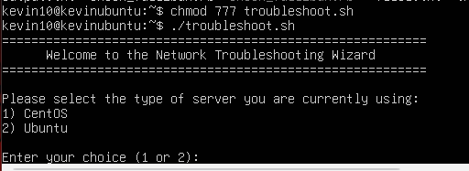

Here I choose 2 and the display shows us how to solve some of the troubleshooting we can have, and the commands that we can use if some of these are our problems in the system.
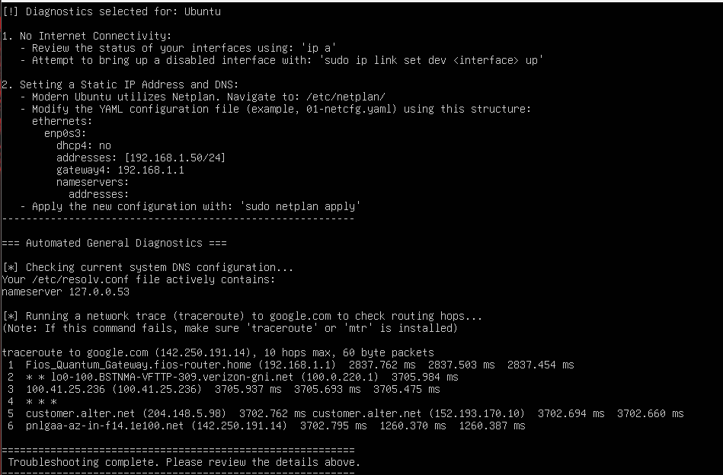
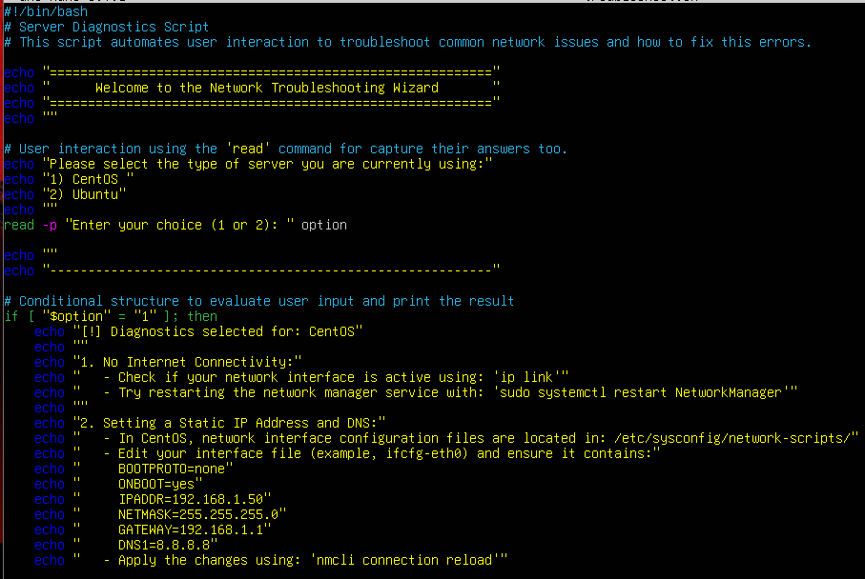
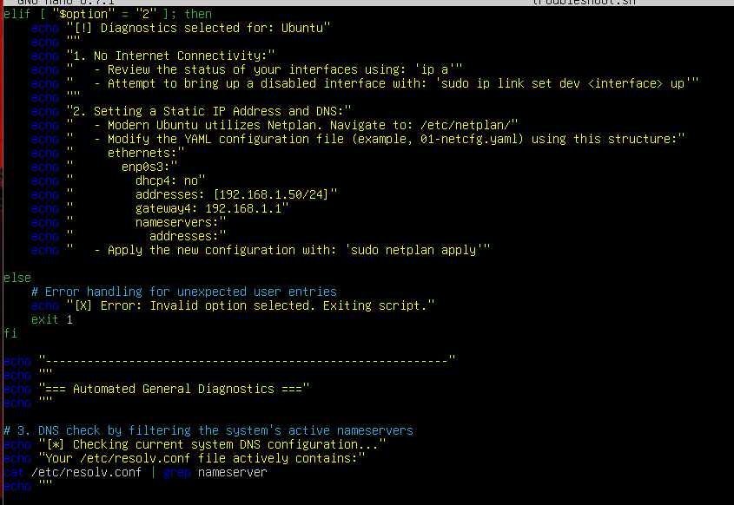
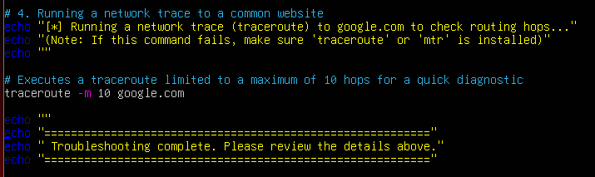
Read -p: this command read the user input before going into the next line.
tee -a: This command will display the output in the terminal and then append the output into a file.
Head and Tail -number: I used this as a combination to limit the output of information from large commands and display the information I wanted from a command. Head beginning. Tail at the end.
echo: the echo command outputs the strings of the written argument.
read $variable$: The read command will read the user input and stored as a variable.
If: the statement starts the decision-making process. It checks whether a specific condition is true or false
Then: the statement connects the condition to the action. It tells the script exactly what to do only if the condition in the if (or elif) statement turns out to be true.
Elif: the statement is used to check a new alternative condition if the previous if condition was false. You can chain multiple elif statements together to test multiple options.
Why do I use this script?
This script is more for helping solve some problems of troubleshooting. We need to write a lot because is explaining problems and the solutions with the commands, I try to give a small manual for solving that, specific for networking.
Sources I use
https://www.geeksforgeeks.org/linux-unix/shell-script-examples/
https://www.aholdengouveia.name/introlinux.html
https://www.aholdengouveia.name/IntroLinux/shellcond.html
https://www.aholdengouveia.name/IntroLinux/shellscripting.html
https://www.aholdengouveia.name/IntroLinux/grepandfriends.html
Gitub Link
https://glorious-guide-g4956jv6gpv9cw5j4.github.dev/

